# **Download Panda ova image**

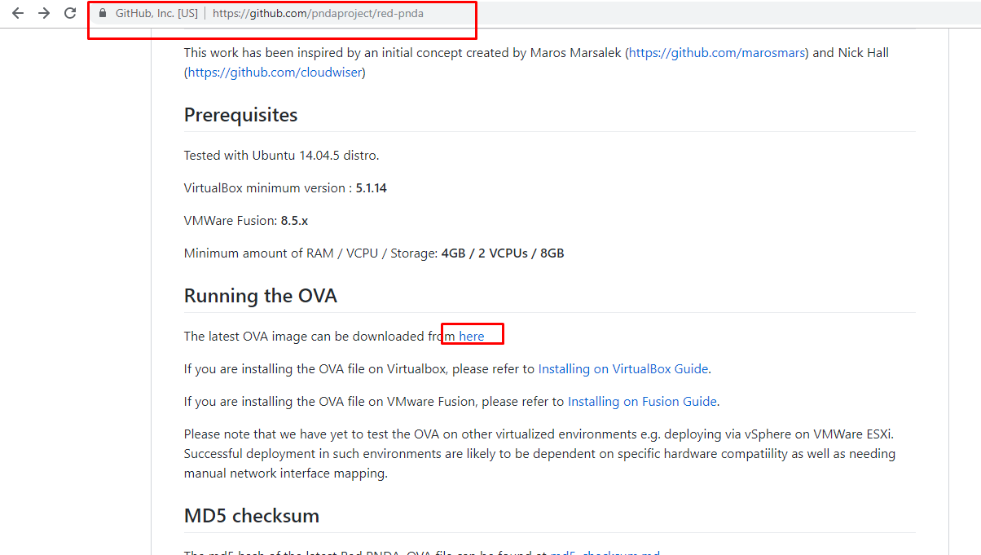

# **Download .ovf convert tool**

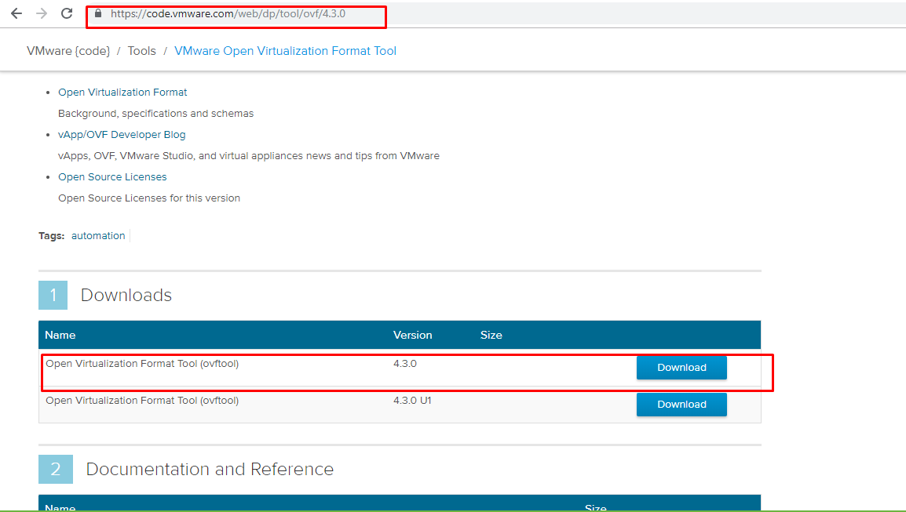

# **Convert the Red-PNDA.ova to the .ovf**



# Then you will see those 3

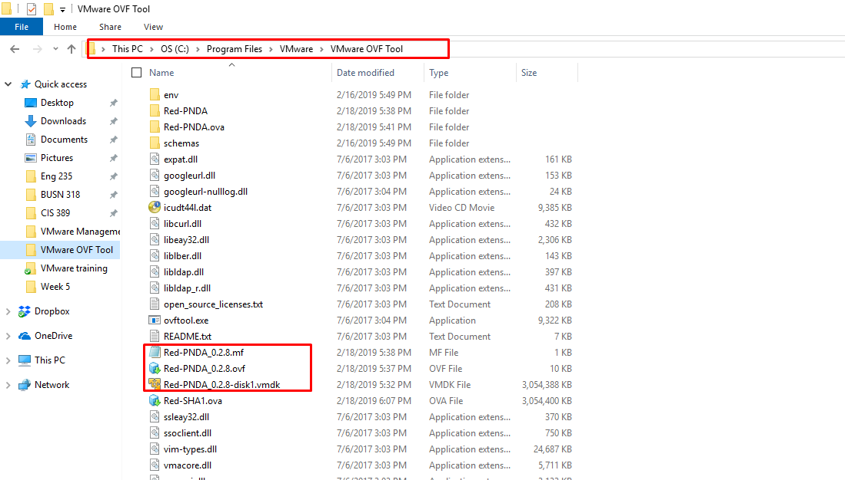

# **Edit the Red-PNDA_0.2.8.ovf file**

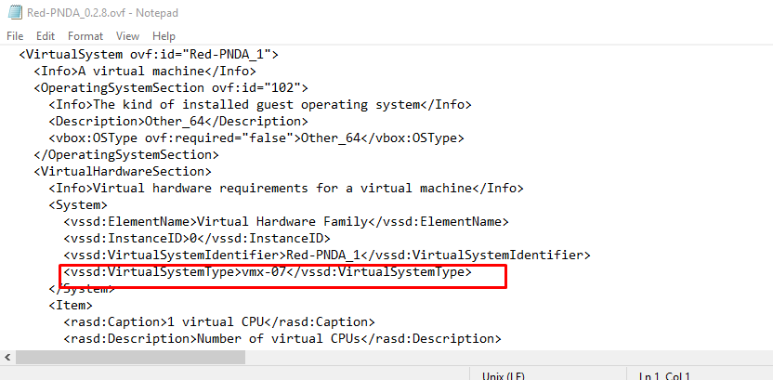

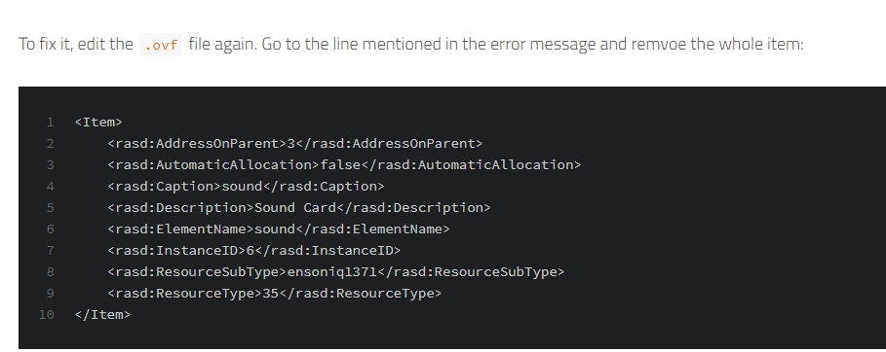

# **Then don’t forget to checksum by using sha256**

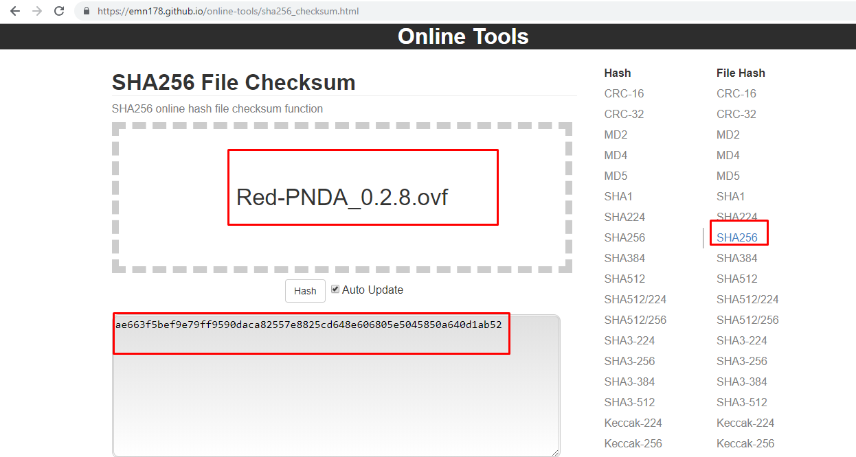

# **Upload it in .mf file**

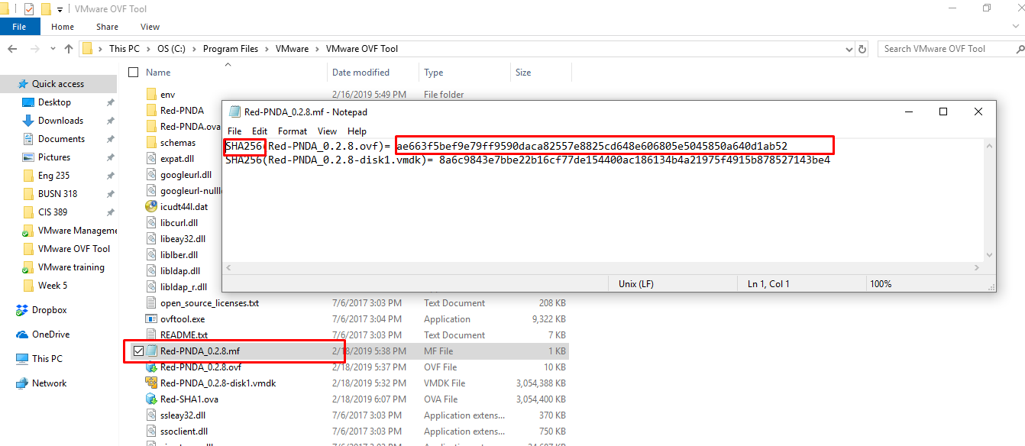

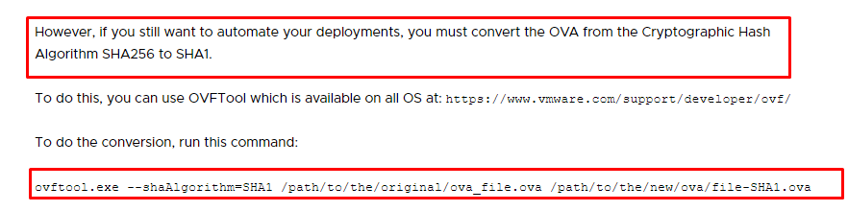

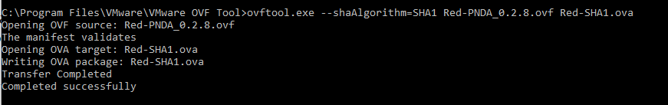

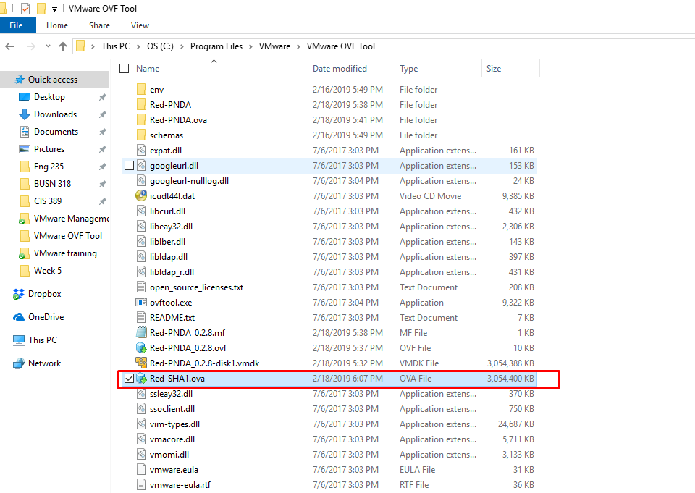

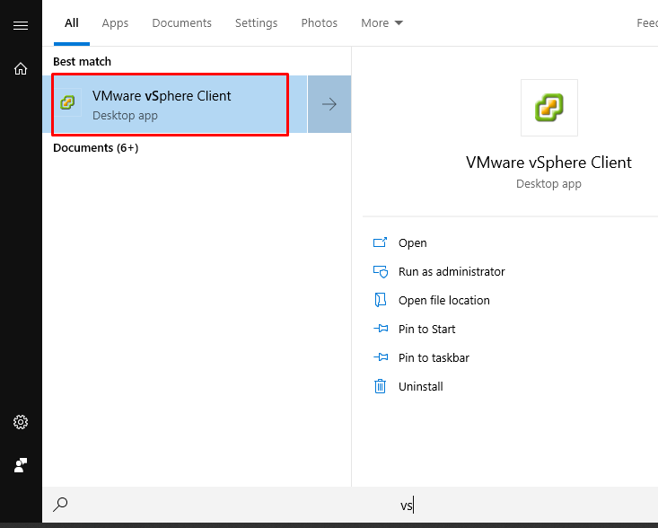

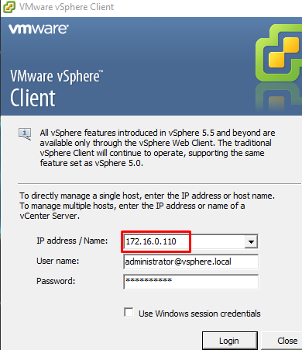

# **Deploy OVF**

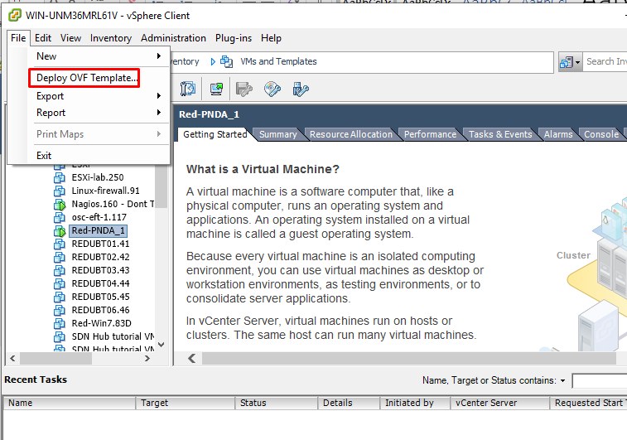

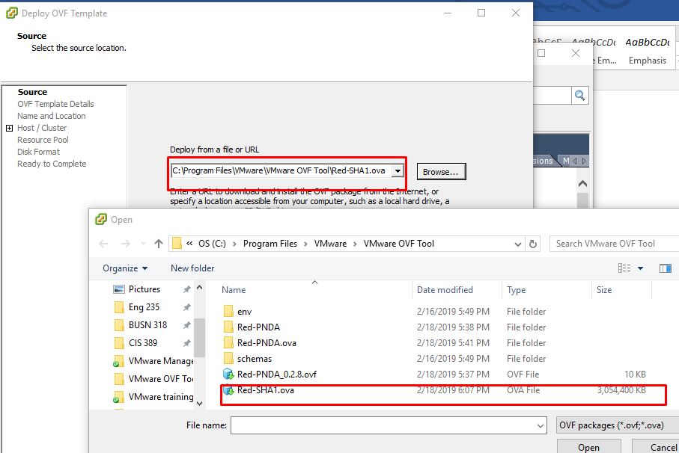

# Then just go next next next.

Power on the machine

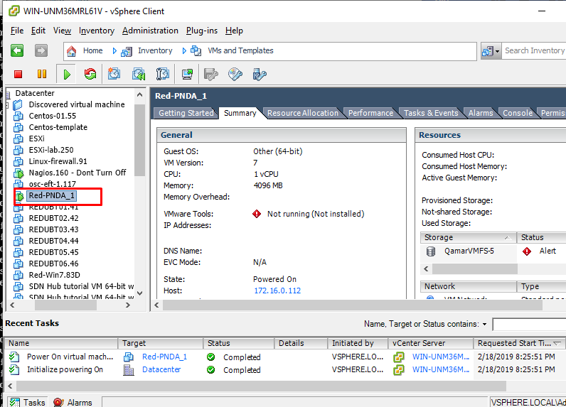

Pnda  
Ip 172.16.0.130  
username: pnda  
password: pnda

# Check the ifconfig

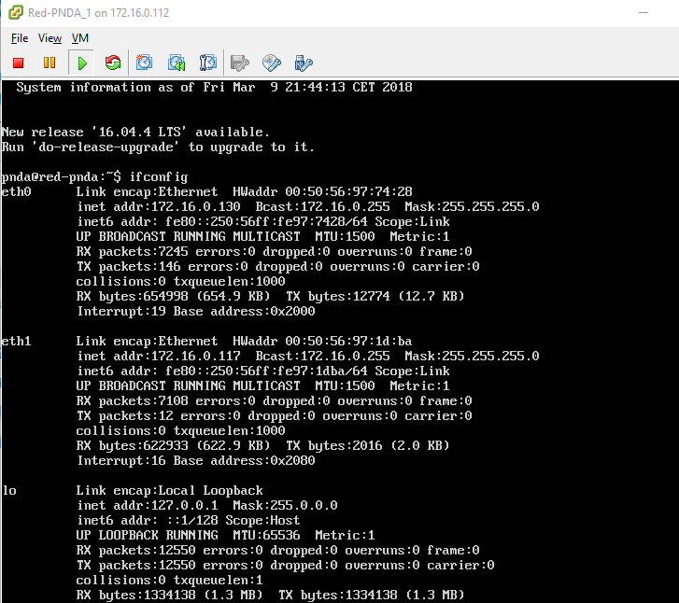

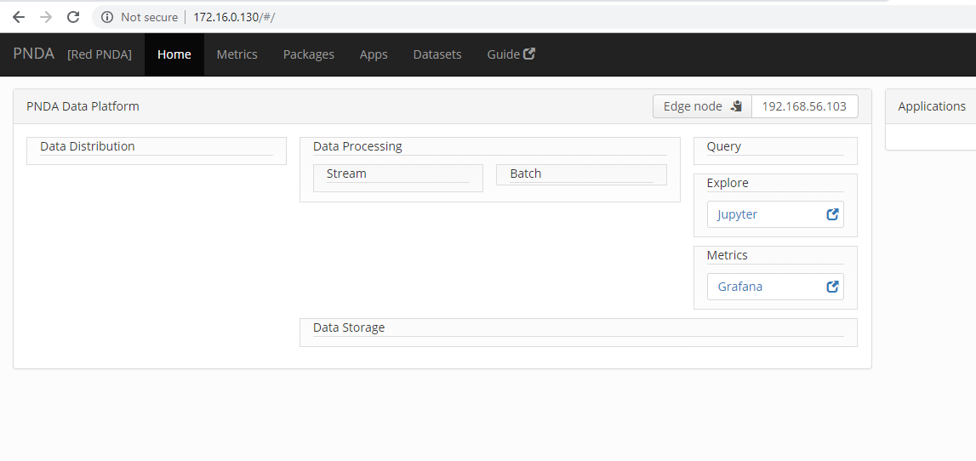

Resource:

<https://kb.vmware.com/s/article/2151537>

<https://jekil.sexy/blog/2015/this-ovf-package-requires-unsupported-hardware.html>